This is a sample of adding chart of accounts for multiple divisions rather than multiple companies.  
The advantage would be less data entry between divisions. For example, as separate companies, company one would place a purchase order for stock box 10x10x10 for company two. Then company two must create a job for the same box 10x10x10. As one company, the only transaction needed is a job created by division two that would replenish inventory for division one. Likewise, as one company, the inventory items are shared, the customers are shared and vendors are shared. To separate reporting by division we have unique general ledger accounts and separate product categories and cost types.

First set Company file in G-F-1.

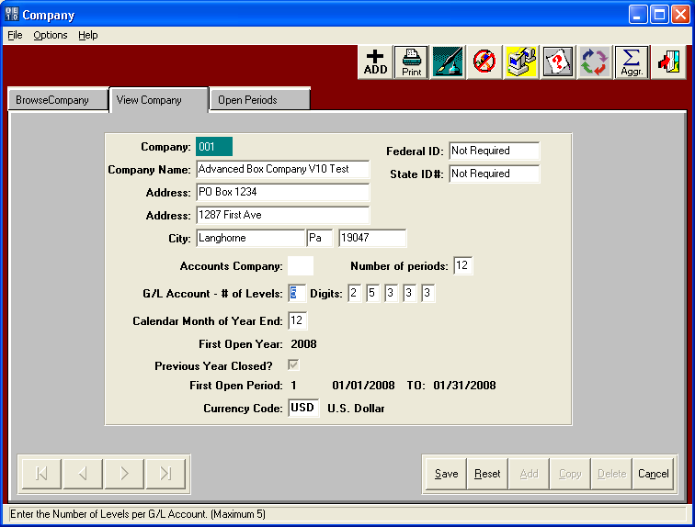

Then you add your GL Accounts.  
The first two numbers are the company code. (For now everything will be 01. If you have an unrelated business in future you can add 02 and get separate P&L and Balance Sheet).  
The 2nd 5 digits would represent the real GL account number.   
 (As you see in attached, 1000 will be for assets, 2000 for liabilities, etc.)  
The 3rd set of digits would represent the DIVISION. 100 = Argrove, 200 = N-Stock, 300 = Company 3, etc.  
The 4th set of digits would represent the DEPARTMENT like Labor by printing or die cutting, or gluing, or PARTS by Breakdown, etc.  
The 5th set of digits would represent a further breakdown within the department such as Parts vs Labor.  
 (For example, Plates vs Motors vs. Gears, vs. Belts for the Printing Department )  
 (Another example may be Printing Labor but by CREW or Shift 1 vs Crew or Shift 2 vs Crew or Shift 3.

For Example

01-30000-100-100-010 Sales Display Division   
01-30000-100-100-020 Sales Display Division Plates  
01-30000-100-100-030 Sales Display Division Dies  
  
01-30000-200-100-010 Sales N-Stock Division  
01-30000-200-100-020 Sales N-Stock Division Plates   
01-30000-200-100-030 Sales N-Stock Division Dies   
  
01-30000-300-100-010 Sales Agrove Division  
01-30000-300-100-020 Sales Agrove Division Plates  
01-30000-300-100-030 Sales Agrove Division Dies

01-50000-100-100-010 Expenses Display Division Printing Department Motors  
01-50000-100-100-020 Expenses Display Division Printing Department Conveyor Belts  
01-50000-100-100-021 Expenses Display Division Printing Department Motor Belts  
01-50000-100-100-030 Expenses Display Division Printing Department Plates  
01-50000-100-100-040 Expenses Display Division Printing Department Gears  
01-50000-200-100-010 Expenses N-Stock Printing Department Motors  
01-50000-200-100-020 Expenses N-Stock Printing Department Conveyor Belts  
01-50000-200-100-021 Expenses N-Stock Printing Department Motor Belts  
01-50000-200-100-030 Expenses N-Stock Printing Department Plates  
01-50000-200-100-040 Expenses N-Stock Printing Department Gears

